Practical 6
Develop application to download image/video from server or upload image/video to server using MTOM techniques
Software Tools Required:
- IDE or Code Editor: Netbeans version 8.0.2
- JDK: java jdk version 8

Project Name: Mtomapplication
Project Architecture:
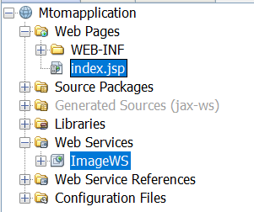

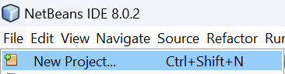

Select Java Web >Web Application
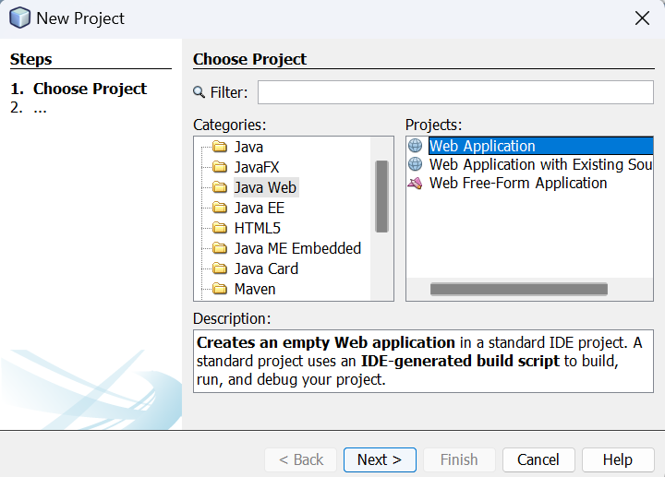
Click Next
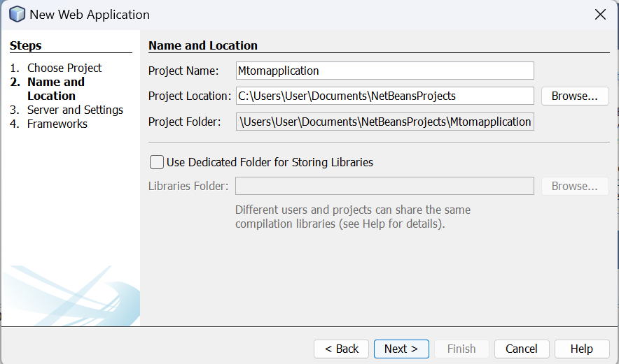

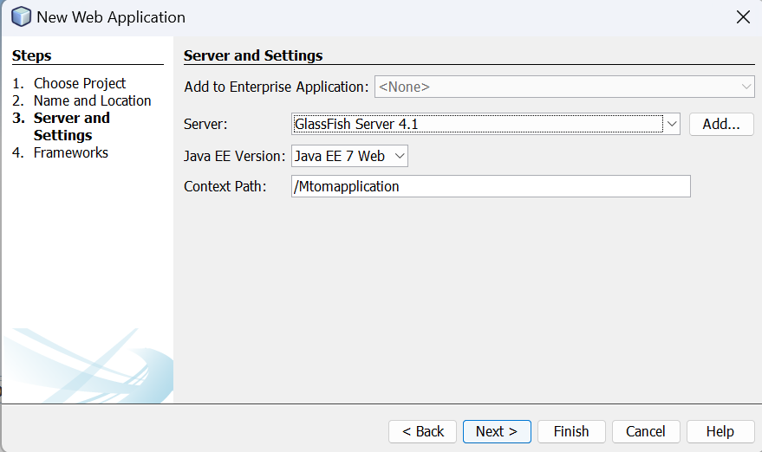
Click Next

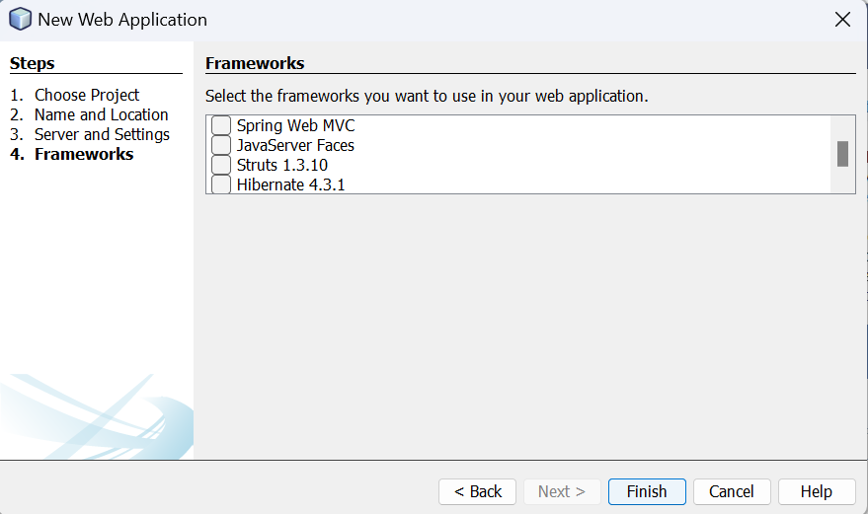
Click Finish

Expand Project Architecture
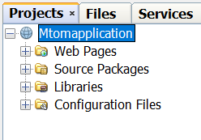
Right Click on Mtomapplication Project New > Web Service
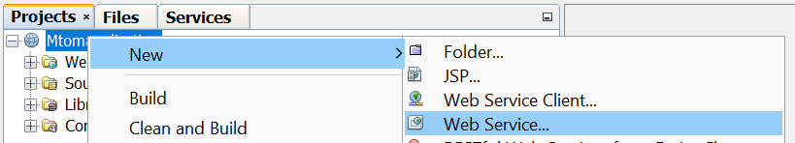

Name: ImageWS and Package: mypkg and Finish
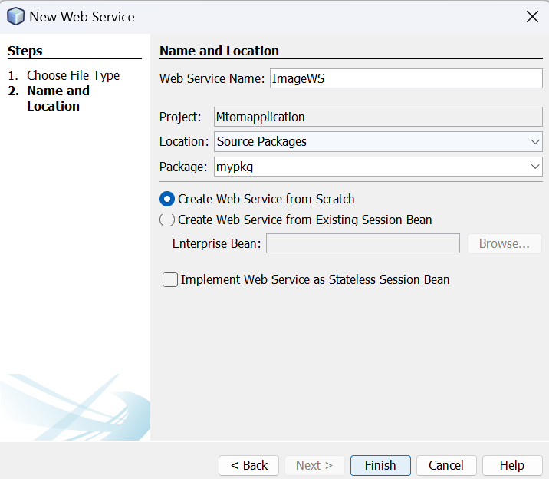

Filename: ImageWS.java
/*
* To change this license header, choose License Headers in Project Properties.
* To change this template file, choose Tools | Templates
* and open the template in the editor.
*/
package pkg;
import java.io.*;
import javax.jws.Oneway;
import javax.jws.WebService;
import javax.jws.WebMethod;
import javax.jws.WebParam;
import javax.xml.ws.soap.MTOM;
@MTOM(enabled = true, threshold = 60000)
@WebService(serviceName = "ImageWS")
public class ImageWS {
@WebMethod(operationName = "upload")
@Oneway
public void upload(@WebParam(name = "Filename") String Filename, @WebParam(name = "ImageBytes") byte[] ImageBytes) {
String filePath = "C:/Users/ankita/Pictures/upload/" + Filename;
try {
FileOutputStream fos = new FileOutputStream(filePath);
BufferedOutputStream bos = new BufferedOutputStream(fos);
bos.write(ImageBytes);
bos.close();
System.out.println("Received file: " + filePath);
} catch (Exception ex) {
ex.printStackTrace();
}

}
@WebMethod(operationName = "download")
public byte[] download(@WebParam(name = "Filename") String Filename) {
String filePath = "C:/Users/ankita/Pictures/upload/" + Filename;
System.out.println("Sending file: " + filePath);
try {
File file = new File(filePath);
FileInputStream fis = new FileInputStream(file);
BufferedInputStream bis = new BufferedInputStream(fis);
byte[] fileBytes = new byte[(int) file.length()];
bis.read(fileBytes);
bis.close();
return fileBytes;
} catch (Exception ex) {
ex.printStackTrace();
return null;
}
}
}

Save File.
Run Project
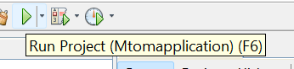

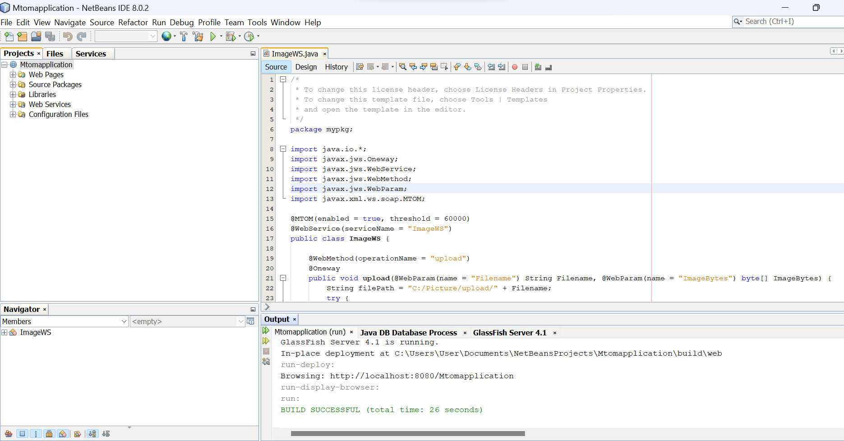

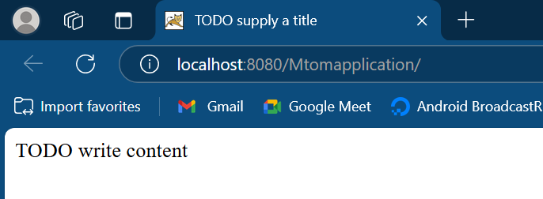

Right Click on Mtomapplication > New > Web Service Client.
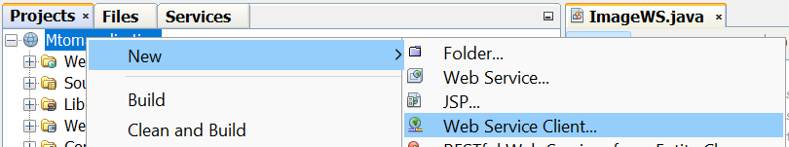

If not available click on Others
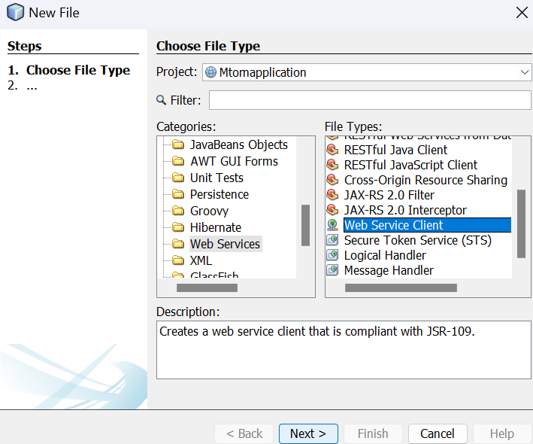

Select on Browse
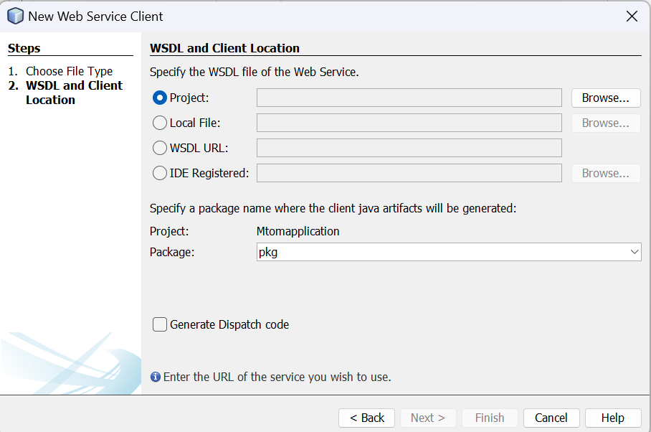
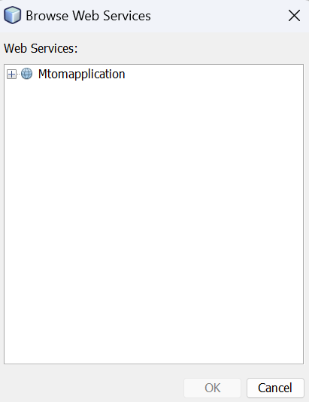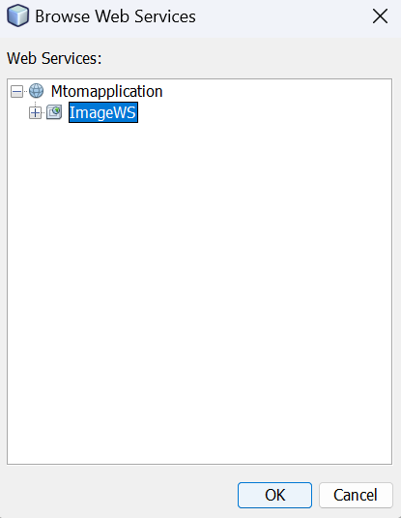

Package: pkg
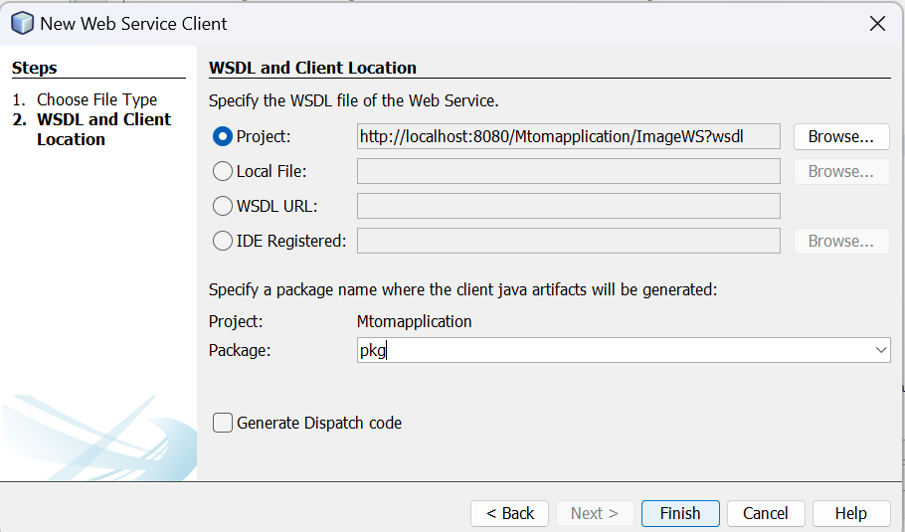
Finish
New > JSP
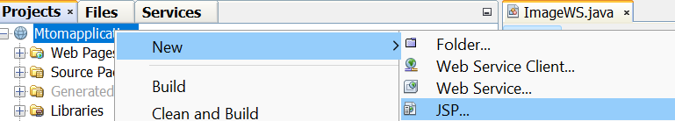
Name: index and click Finish
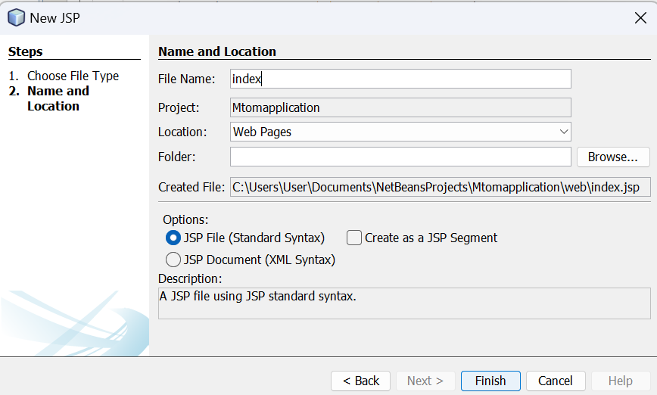
Filename: index.jsp
<%--
Document : Index
Created on : 17 Dec, 2025, 6:19:14 PM
Author : ankita
--%>
<%@page import="java.io.BufferedOutputStream"%>
<%@page import="java.io.FileOutputStream"%>
<%@page import="java.io.FileInputStream"%>
<%@page import="java.io.BufferedInputStream"%>
<%@page import="java.io.File"%>
<%@page import="javax.xml.ws.soap.MTOMFeature"%>
<%@page contentType="text/html" pageEncoding="UTF-8"%>

<!DOCTYPE html>
<html>
<head>
<meta http-equiv="Content-Type" content="text/html; charset=UTF-8">
<title>JSP Page</title>
</head>
<body>
<%-- start web service invocation --%><hr/>
<%
try {
mypkg.ImageWS_Service service = new mypkg.ImageWS_Service();
mypkg.ImageWS port = service.getImageWSPort(new MTOMFeature(60000));
// TODO initialize WS operation arguments here
String filePath="C:/Users/ankita/Pictures/abcd2.jpg"; // Assuming this is the correct file path
File file=new File(filePath);
FileInputStream fis=new FileInputStream(file);
BufferedInputStream bis=new BufferedInputStream(fis);
String filename = file.getName();
byte[]imageBytes=new byte[(int)file.length()];
bis.read(imageBytes);
port.upload(filename, imageBytes);
bis.close();
out.println("File uploaded :" + filePath);
} catch (Exception ex) {
// TODO handle custom exceptions here
ex.printStackTrace();
}
%>
<%-- end web service invocation --%><hr/>
<%-- start web service invocation --%><hr/>
<%
try {
mypkg.ImageWS_Service service = new mypkg.ImageWS_Service();
mypkg.ImageWS port = service.getImageWSPort();
// TODO initialize WS operation arguments here
String filename = "abcd2.jpg"; // Assuming this is the correct file name
// Initialize filePath
String filePath = "C:/Users/ankita/Pictures/download/" + filename; // Assuming this is the correct download path
// Invoke the download method and get the file bytes
byte[] fileBytes = port.download(filename);
// Write the downloaded bytes to a file
FileOutputStream fos = new FileOutputStream(filePath);
BufferedOutputStream bos = new BufferedOutputStream(fos);
bos.write(fileBytes);
bos.close();
out.println("File downloaded: " + filePath);
} catch (Exception ex) {
// TODO handle custom exceptions here
ex.printStackTrace();
}
%>
<%-- end web service invocation --%><hr/>
</body>
</html>

Create a Folder Name: Picture inside
Create 2 Folders name: download and upload and an image with name abcd2 or any name with proper extension
Here image name and extension: abcd2.jpg
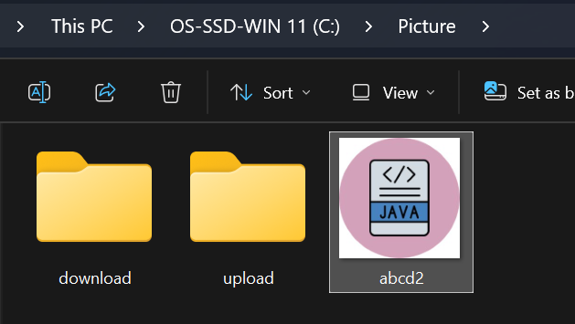

Deploy Project
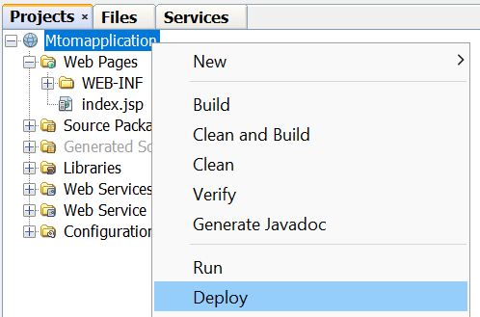

Then Run Project or F6



